**INTRODUCTION**

* The Sunshine Service is a Incorporated Society and Charitable Organisation set up in 1982 in response to findings by the Aged Peoples’ Welfare Council. Research showed there was no appropriate transport for older or disabled persons living in Gisborne. Many of these people needed and wanted to attend medical appointments and participate in community activities etc.
* The Service began with a volunteer committee of twelve. A vehicle with a hydraulic hoist was adapted for wheelchairs and people with walking frames.
* Today the Service has three full height, purpose built vans with hydraulic hoists.
* The volunteer drivers are rostered to drive the vehicles each week day. Most of these drivers are retired persons wishing to give something back to their community.
* Drivers undergo special training and have to pass a driving competency test.
* The Service offers a personalised door to door service and each driver is accompanied by an assistant.

**SOME VITAL FACTS**

* A Manager is employed five mornings a week to receive bookings, organise the driving rosters and maintain contact with clients and drivers.
* The Service has an excellent safety record. The vehicles are serviced regularly and comply with all safety requirements.
* Each van is equipped with a radio telephone to enable the Manager to maintain contact with each driver and drivers to communicate with each other through the inter vehicle link.
* Statistics for the year show that over a 49 week period the three vans:
* Made more than 6678 single passenger trips
* Included in that were over 1634 wheelchairs and walking frame passengers.
* Travelled 37,878 kilometres.
* The above figures were adversely affected by Covid19.
* The Service was unique to Gisborne for many years but has now been copied in other centres. With an average of 350 passengers trips each week the Service enables up to 130 clients in any one week to go to their medical, dental, physio, optical etc., appointments, attend Day Care, recreational or social activities, do their banking, shopping, visit the library, or attend cultural or other activities.
* Voluntary support groups such as Stroke Support, Parkinson’s Society, Arthritis Foundation, Idea Services, Blind Foundation, CCS, Alzheimers, Care and Craft, Arohaina, Day Cares and the Dialysis Unit use the Service to transport their members to and from meetings and activities. It would be difficult for the voluntary agencies to function without the Sunshine Service.

**HOW YOU CAN USE THE SERVICE**

* The Service is pre-booked and is available to elderly or disabled persons living in Gisborne City, Makaraka and Wainui.
* Bookings must be made 24 hours in advance.
* Bookings can be made by phoning the Manager in the office between 8.00 am and noon on weekdays. Outside those hours, a message can be left on the office answerphone.

**PHONE NUMBER**

**867-2905**

* Any cancellations should be made by 8.00 am on the day of the booking or even earlier where possible.
* The driver’s instructions are as per the booking, i.e. from the home address to the booked destination.
* Clients must be eligible to use the Service, i.e. elderly or disabled
* Drivers will collect a charge of $3 one way or $5 return. Drivers ***do not*** have EFTPOS and no change is carried.

**WAYS YOU CAN HELP US**

* Additional donations can be made to:

The Sunshine Service

P O Box 937

Gisborne 4040

* You can also remember the Sunshine Service in your Will, by donating to our Special Interest Fund at Sunrise Foundation P O Box 1068, Gisborne
* Donation Tax Credit Claims-these can be claimed at any time during the year via the myIR website
* Join our volunteer group as a driver or an assistant.
* Let your neighbour or friends know about our transport service.

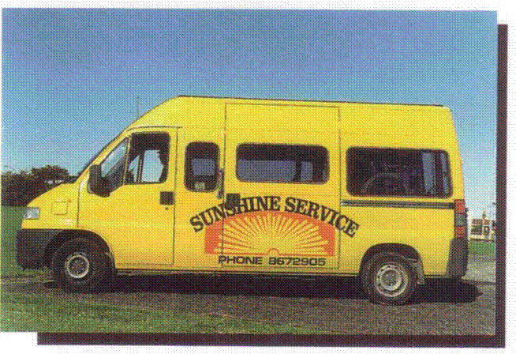

**SUNSHINE**

**SERVICE**

**A USER FRIENDLY**

**DOOR-TO-DOOR**

**TRANSPORT SERVICE**

**For Gisborne’s disabled and older persons**

He kaupapa tautoko I te hunga

pakeke me te hunga mauiui o

Turanga

**Phone**

**8672905**

**P O Box 937**

**Gisborne 4040**

sunshineservice@xtra.co.nz